**KEEP CURRENT THROUGH ASSIGNMENT BOOKS, CLASS WEBSITE, REMIND 101,**

**AND FAMILY ACCESS**

***GRADING ADHERES TO DISTRICT POLICY:***

**JOIN FAMILY ACCESS…VISIT OFFICE TO ACQUIRE A CODE TO VIEW GRADES.**

**HOMEWORK/QUIZZES**: 60% OF GRADE TOTAL

**TESTS:** 40% OF GRADE TOTAL

**ZERO** IS EARNED FOR WORK NOT TURNED IN ON TIME, AND NO REDO ALLOWED.

**REDOES:** BELOW 70% GRADE IS ALLOWED A REDO **IF** THE WORK IS 70% OR MORE COMPLETED **AND** ON TIME.

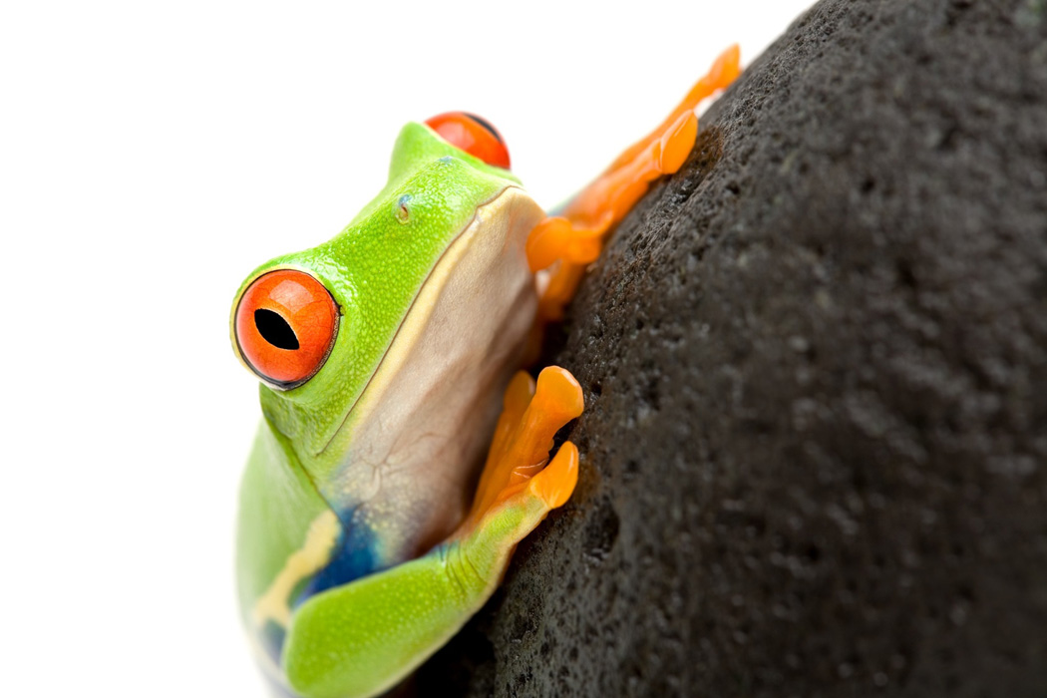

Tutorials:

Wednesdays 7:20-7:45am

STUDENTS/PARENTS WILL USE CLASS WEBSITE

http:// **mrsmooresciencelab.weebly.com**

**STAY CURRENT IN LEARNING ACTIVITIES AND**

**CALENDAR OF EVENTS.**

**SOME ASSIGNMENTS WILL USE**

**WEBSITE.**



6TH GRADE IS A NEW EXCITING CHALLENGE….LET’S TEAM TOGETHER TO CONQUER THE YEAR. CONTACT ME WITH ANY QUESTIONS/CONCERNS.

**SCIENCE TEXTBOOK**

**A science textbook will be checked out to each student and is to stay at home for assignments and as a reference guide.**

**“REALLY, REALLY, REALLY IMPORTANT”**

**USE AND CHECK ASSIGNMENT BOOK**

STUDENTS ARE RESPONSIBLE FOR WRITING THE POSTED ASSIGNMENT DAILY. THERE SHOULD ALWAYS BE A SCIENCE POSTED STATEMENT WRITTEN. **DON’T ACCEPT THE COMMENT**, “WE DIDN’T HAVE TO WRITE AN ASSIGNMENT”

Science supplies:

2 composition notebooks: 1 for fall and 1 for spring semesters

Red Homework folder, 1 science folder with brads

Flashdrive

HERE’S IMPORTANT INFORMATION FOR YOU TO KNOW TO GET YOUR YEAR STARTED.

My Contact Information:

[mooree@whitehouseisd.org](mailto:mooree@whitehouseisd.org)

903/839-5656

Via SMS

Enter (903)871-1647 with message @moorescie

www.remind.com/join/moorescie

Remind 101 for parents.

Get up to date class information by staying connected.

Download/register 1 of 3 ways



SCIENCE LAB 2 ROCKS WITH LEARNING

WELCOME TO 6TH GRADE SCIENCE